**CALENDER**

**PPS MINI PROJECT**

**NAME:** S Prem Kumar

**REG NO:** RA2111009010073

**NAME:** Chirayu C

**REG NO:** RA2111009010071

**CODE:**

// C program to print the month by month

// calendar for the given year

#include <stdio.h>

// Function that returns the index of the

// day for date DD/MM/YYYY

int dayNumber(int day, int month, int year)

{

static int t[] = { 0, 3, 2, 5, 0, 3,

5, 1, 4, 6, 2, 4 };

year -= month < 3;

return (year + year / 4

- year / 100

+ year / 400

+ t[month - 1] + day)

% 7;

}

// Function that returns the name of the

// month for the given month Number

// January - 0, February - 1 and so on

char* getMonthName(int monthNumber)

{

char* month;

switch (monthNumber) {

case 0:

month = "January";

break;

case 1:

month = "February";

break;

case 2:

month = "March";

break;

case 3:

month = "April";

break;

case 4:

month = "May";

break;

case 5:

month = "June";

break;

case 6:

month = "July";

break;

case 7:

month = "August";

break;

case 8:

month = "September";

break;

case 9:

month = "October";

break;

case 10:

month = "November";

break;

case 11:

month = "December";

break;

}

return month;

}

// Function to return the number of days

// in a month

int numberOfDays(int monthNumber, int year)

{

// January

if (monthNumber == 0)

return (31);

// February

if (monthNumber == 1) {

// If the year is leap then Feb

// has 29 days

if (year % 400 == 0

|| (year % 4 == 0

&& year % 100 != 0))

return (29);

else

return (28);

}

// March

if (monthNumber == 2)

return (31);

// April

if (monthNumber == 3)

return (30);

// May

if (monthNumber == 4)

return (31);

// June

if (monthNumber == 5)

return (30);

// July

if (monthNumber == 6)

return (31);

// August

if (monthNumber == 7)

return (31);

// September

if (monthNumber == 8)

return (30);

// October

if (monthNumber == 9)

return (31);

// November

if (monthNumber == 10)

return (30);

// December

if (monthNumber == 11)

return (31);

}

// Function to print the calendar of

// the given year

void printCalendar(int year)

{

printf(" Calendar - %d\n\n", year);

int days;

// Index of the day from 0 to 6

int current = dayNumber(1, 1, year);

// i for Iterate through months

// j for Iterate through days

// of the month - i

for (int i = 0; i < 12; i++) {

days = numberOfDays(i, year);

// Print the current month name

printf("\n ------------%s-------------\n",

getMonthName(i));

// Print the columns

printf(" Sun Mon Tue Wed Thu Fri Sat\n");

// Print appropriate spaces

int k;

for (k = 0; k < current; k++)

printf(" ");

for (int j = 1; j <= days; j++) {

printf("%5d", j);

if (++k > 6) {

k = 0;

printf("\n");

}

}

if (k)

printf("\n");

current = k;

}

return;

}

// Driver Code

int main()

{

int year = 2022;

// Function Call

printCalendar(year);

return 0;

}

Visual Studio Code:

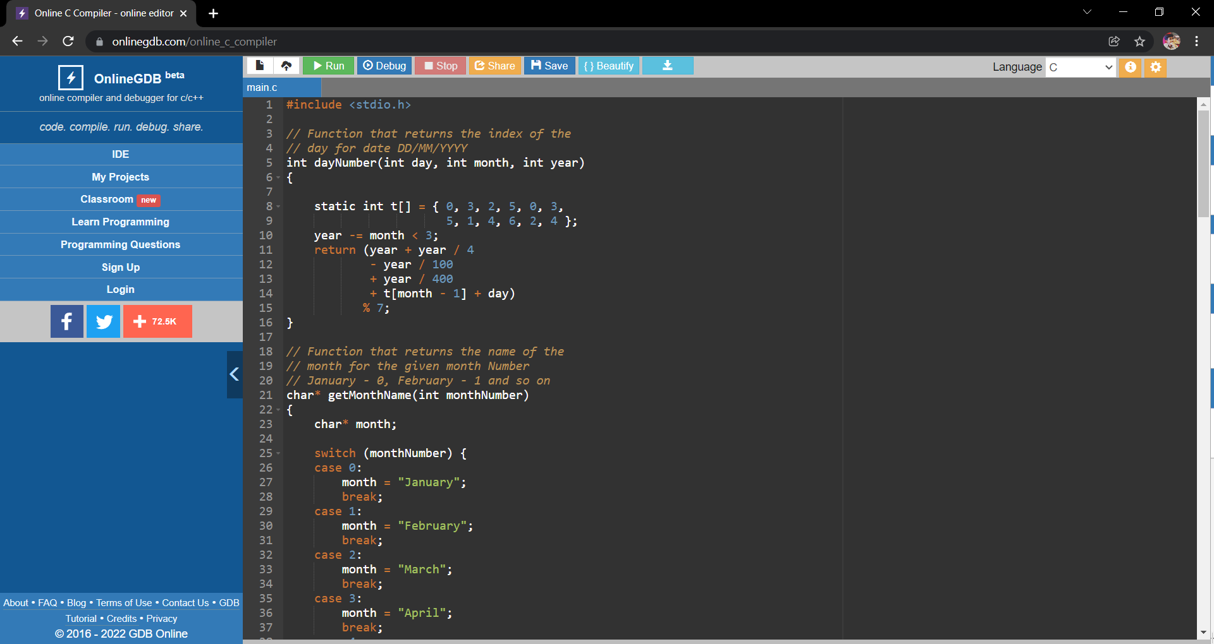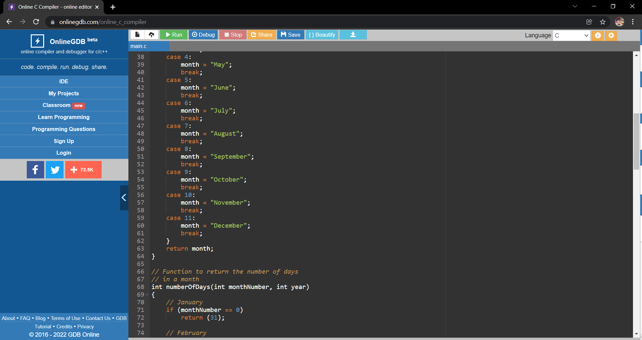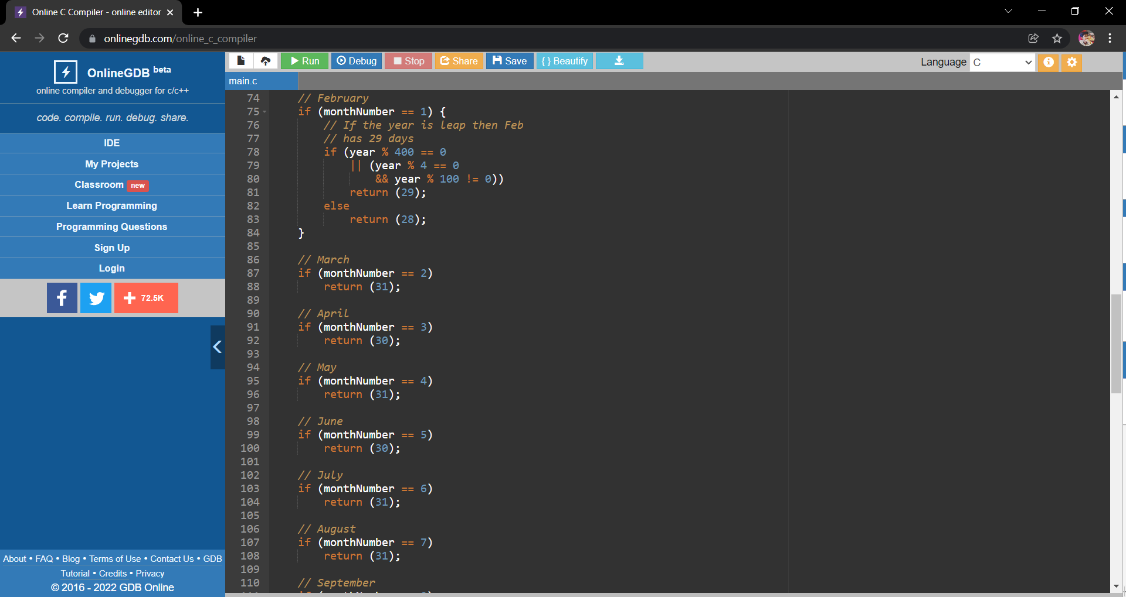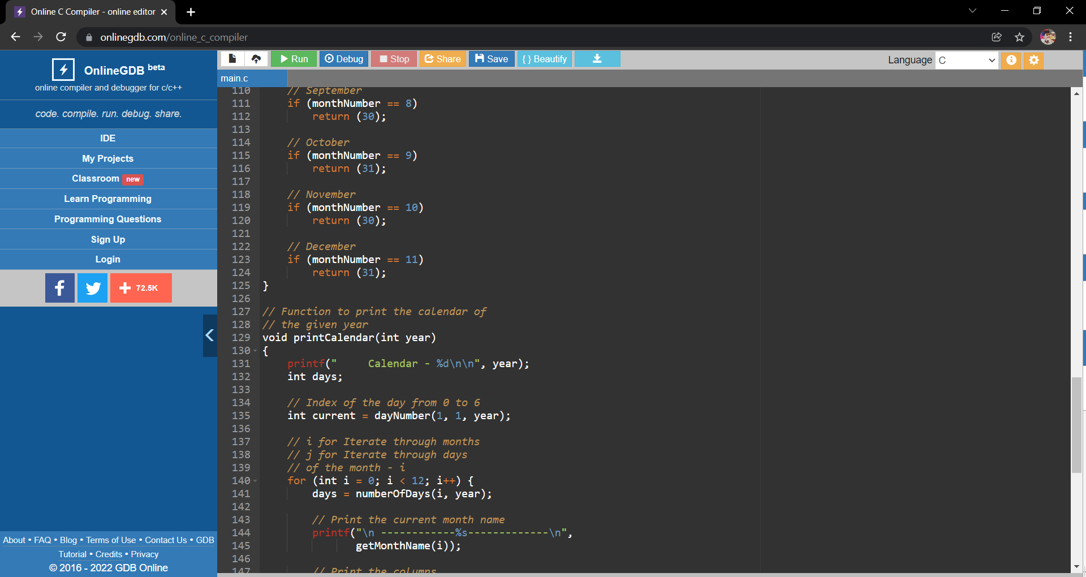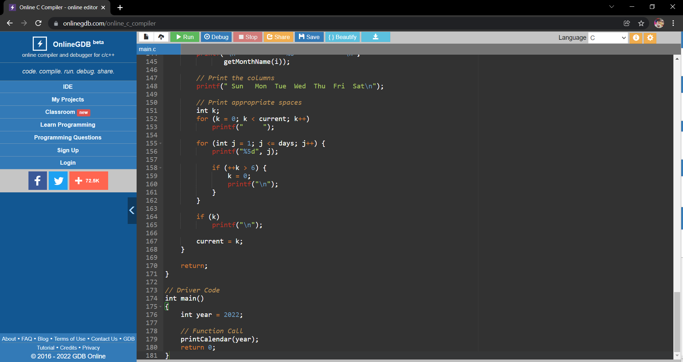

Output:

